**DO YOU LOVE ART?** 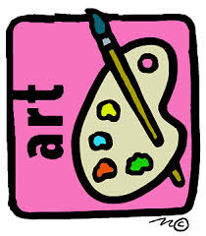

**Fairhope Middle School is offering Advanced Art Classes for students who want to further develop their talent. Space is limited, and an art portfolio is required. Both 7th and 8th graders are eligible to submit their artwork for consideration. The Advanced Art Classes are responsible for creating the artwork that is displayed throughout the school.**

**If you would like to be considered for the Advanced Art Class in 7th grade, you will need to email photos of up to 3 works of art labeled with your name to Mr. Johnson, the FMS Art Teacher.**

**You will also need one teacher recommendation related to behavior. This form should be given to your teacher for him/her to email to Mr. Johnson. For more information, please contact Mr. Johnson, the FMS Art Teacher, at** [**SJohnson@bcbe.org**](http://SJohnson@bcbe.org)